Name: __________________
Date: ___________________
Class: __________________

Metric Me
Due on:________

Your task is to draw a recognizable version of yourself in which all your vertical measurements are exact but have been compressed to make you 15.5 centimeters (about 6 inches) wide. Your portrait will be displayed in the pod and your podmates should be able to find you easily amongst the portraits. You will plot a total of 17 metric measurements in addition to your mass in Kilograms (Kg) and your weight in Newtons (N).

1. Use the scientific equipment on the counters and the directions on your Metric Me measurement sheet to take accurate measurements of your body. Record your measurements on your sheet. You will then convert each measurement into a different metric unit using your Metric Staircase.

2. Once all your measurements have been determined, plot the measurements onto the skeleton illustration using the proper format for science drawings. Obtain a piece of white, thin paper approximately 2 meters long (about 79 inches).

3. Put your name, class, and date on the back of the white paper.

4. Use the metric measurements you have made to plot an outline of yourself. Begin with your total height from the bottom and then add progressively smaller measurements.

5. Make yourself recognizable by coloring in your features, style of clothing and any distinguishable characteristics (hair line and texture, birthmarks, freckles, etc)
Metric Me Measurements

- Use the required tools to obtain the correct metric measurements listed below.
- Use your metric staircase to convert to the correct metric unit.

# | Measurement | Tool Used | Original | Converted
1 | Top of head to floor | Carpenter’s Rule | cm | dm
2 | Waist to floor | Meter stick | cm | Hm
3 | Waist to top of knee | Meter stick | cm | mm
4 | Waist to chin | Dressmaker’s Tape | cm | Dm
5 | Bottom of knee to ankle | Meter stick | cm | Hm
6 | Top of shoe to floor | Ruler | cm | mm
7 | Shoulder to tip of middle finger | Carpenter’s Rule | cm | m
8 | Shoulder to top of head | Ruler and Block | cm | dm
9 | Middle finger tip to wrist | Ruler | cm | mm
10 | Wrist to elbow | Calipers | cm | Dm
11 | Length of middle fingernail | Dressmaker’s tape | cm | mm
12 | Chin to top of head | Calipers | cm | m
13 | Chin to pupil of eye | Calipers | cm | dm
14 | Chin to middle of lips | Sewing calipers | cm | m
15 | Height of lips | Paper tape and ruler | cm | Dm
16 | Length of nose | Sewing Calipers | cm | m
17 | Top of head to bottom of earlobe | Ruler and Block | cm | dm
18 | Mass in Kilograms | Kilogram Scale | Kg | g
19 | Weight in Newtons (use answer 18 to calculate)  Use the formula:  Weight=  Mass (Kg) x 9.8m/s² (gravity) | Calculator | Newtons | No conversion
Metric Key:
Kilometer (Km) Hectameter (Hm) Dec(k)ameter (Dm) Meter (m)
decimeter (dm) centimeter (cm) millimeter (mm) Kilogram (Kg)
Procedure:
- Work with partner to complete your Metric Me Data Table
- Plot measurements 1-17 on this drawing
- Use pencil, ruler and horizontal lines for each measurement
- Use brackets and lines as shown below
- Show proper units for of measurement on lines

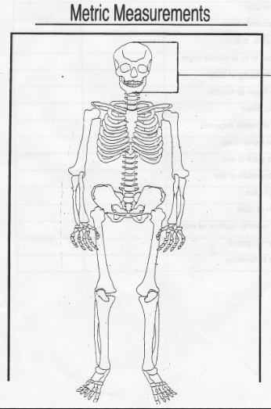
cm

Metric Me Grading Rubric

Your Metric Me Project is worth 100 points and is due on ___________________.
We’ve had several days in class to complete the project so anything not finished by __________________ should be completed at home.

Your project will be graded on the following components:
Total: 100 points ______

Original and Converted measurements (w/ units) 10 points_____________
Skeleton-colored, labeled, using a ruler, neat 10 points_____________
General Appearance-attention to detail 10 points_____________
Metric Me Drawing 70 Points (total)
- Features in correct locations 30 points______________
- Accurate total height 10 points______________
- Full size hands 10 points______________
- Colored-clothes, hair, body, etc. 10 points______________
- Resembles student 10 points______________

Please ensure that your Metric Me meets all of the above requirements before turning it in on. You must have this sheet to turn in with your project. Thank you!

